CCNA2 Case Study v.1.01 Fall 2024

Group work with a maximum of three students.

Design and configure network for Acme Ltd. Use real equipment on Lab KMD658. Labswitch and Labrouter are preconfigured. Connection to Labnetwork is through RJ45 connectors named Labnetwork 10.95.0.0/23)in conduits on walls.

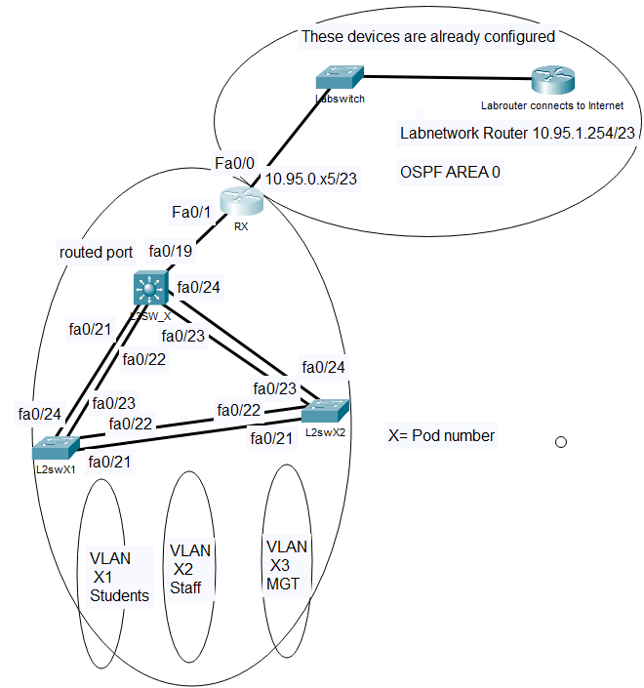

Each group has its own IP address range available according to the pod number (x). For example, pod 7 has IP addresses 10.95.70.0 -10.95.79.255 available plus the IP for connection to Labnetwork 10.95.0.75/23.

Reserver a pod for your group use by using following link: <https://docs.google.com/spreadsheets/d/1LNcfPSst9bT6CqVl2GqtYxpIrh977mRr0fzDagson3Y/edit?usp=sharing>

1. Configure Rx:s fa0/0 interface with the IP address of 10.95.0.x5, where x is the pod number (from 1 to 13). Connect that interface to labnetwork (socket marked with text labnetwork 10.95.0.0/23). Check that you can ping labrouter 10.95.1.254.
2. Design the IP addressing plan according to the following requirements: Students VLAN (X1) must have space for at least 600 users, Staff VLAN must have space for at least 70 users and MGT VLAN space for 50 devices. You can use the address range 10.95.x0.0 -10.95.x9.255., where x is your pod number. Remember also to reserve addresses for the link between Rx and L3SW_X
3. On Router Rx configure routes towards L3Sw_X VLANs and configure it to use single are OSPF routing protocol and advertise those static routes and connected networks to labnetwork with the following commands:  
   router ospf 1  
   network 10.95.0.0 0.0.1.255 area 0

redistribute static metric 10 subnets

redistribute connected metric 10 subnets

1. Verify that you can connect to internet by pinging google’s public DNS server ip address 8.8.8.8
2. Configure static default route on L3SW_X towards Rx.
3. Use Per VLAN Spanning Tree plus as Spanning Tree protocol on the switches
4. Configure L3SW_X to be spanning tree root for all VLANs.
5. Configure parallel Ethernet links as Etherchannel trunks, were only VLANs x1,x2 and X3 are allowed.. Change load-balance method to src-dst-ip
6. Ports fa0/1-5 on all switches should be configured as accessports for VLAN X1, Ports fa0/6-10 for VLAN X2, Ports fa0/11-12 for VLAN X3.
7. Configure ports fa0/1-12 with port security enabled and configured with spanning tree portfast. The maximum number of MAC addresses per access port is 2 to allow a Bridged Virtual machine. Portsecurity violation should cause the port to go to shutdown state. Configure also BPDU guard on all accessports.
8. All unused ports should be put in shutdown state
9. In every VLAN there has to be a DHCP server. Reserve 30 IP-addresses in each VLAN for devices with static IP addresses. Configure DNS-server to be provided to DHCP clients to be 8.8.8.8.
10. Configure NTP to synchronize clocks between Switches and end devices and configure also correct time zones (EET) and also summertime transition rules (EEST). Configure two NTP servers: 10.94.1.3 and 10.94.4.254)
11. Configure all switches and router to support SSH version 2 and disable telnet to them. Domain name is iotlab.metropolia.fi. For login authentication on switches configure all switches to use the local database (database must have a user cisco with password class configured for privilege level 1 access and a second user admin with password ciscoeigrp for privilege level 15 access).
12. Configure DHCP snooping for VLANs X1, X2 and X3, and only trust trunk ports connecting switches.
13. Configure Dynamic ARP inspection for VLANs X1, X2 and X3.
14. L2 switches should have only static IP address in the MGT VLAN with default gateway configured to be able to update time through

Test your implementation of case study and connect a pc to all VLANs and verify that you can connect to the internet. Write a detailed group report where you explain how the requirements were configured to devices (what command were used and their possible limitations) and explain how and what test were performed and any shortcomings found during testing. Include all configurations from all network devices as appendix to your report. Include also a network diagram with IP addresses clearly visible in it. Answer questions presented at the end of this case study. State clearly in the report the names of the students doing the report. Only one submission of the group report is needed. As there are two Classes using the same routers, copy configurations to notepad files and erase startup-configs when you stop working. When you continue to work with the case study, verify that the network devices are first with default configuration, and after that you can just paste your configuration to devices through terminal. Remember to issue no shutdown command on router interfaces.

The deadline for the case study is Sunday 20.10 at 23.59

If You are uncertain about requirements of this Case Study or if you get stuck in some problems when implementing, don’t hesitate to contact me for advice: tel +358 50 3535 975 or email: [marko.uusitalo@metropolia.fi](mailto:marko.uusitalo@metropolia.fi).

When you answer following questions, include the relevant IoS command with output of it:

1. How many links will L3Sw_x see in spanning-tree?

Answer: 2 links for each VLAN (6 total links from VLAN X1, X2, and X3)

1. What is the router ID of labrouter?

Answer: 10.95.1.36

1. How many OSPF routes did the Rx receive? (show ip route ospf)

Answer: 43 routes

1. How many OSPF neighbors did Rx have? (show ip ospf neighbor)

Answer: 10 neighbors

1. Were there any requirements in this Case Study that you were unable to fulfill?

Answer:

1. How you could improve security and performance of the network in your implementation of case study?

Answer:

1. **How much time did this Case Study take?**

Answer: Around 9 hours included on Monday 30th September and also Wednesday 2nd October from afternoon until the evening.

**In report: explain the commands to get the results, how you have tested that everything works (Copy paste the configuration for all devices)**

**-Take some pictures of real router examinations and also some screenshots**

**-Explain the mistakes encountered and how to solve them…..** (Ex: Iconnectivity occurred in our group / forgot to configure the IP address in the router and also we had pinged in different platform (or) interfaces with wrong connections)

**It’s good to include screenshots in the report also.**